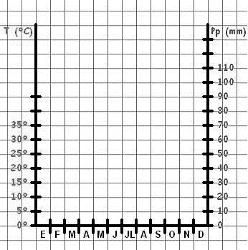
CLIMOGRAMA ____________________________________________________

El tipo de clima que presenta esta zona es
______________________________________________________________________________________________________________________

Este clima se caracteriza por
____________________________________________________________________________________________________________________________________________________________________________________________________________________________________________________________________________________________________________________________________

* Material del colegio San Joaquín basado en material del Colegio Sagrados Corazones de Manquehue

